**INPUT FILE FOR WORD COUNT**

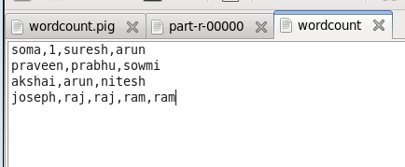

**Pig FILE TO BE EXECUTED FOR WORD COUNT**

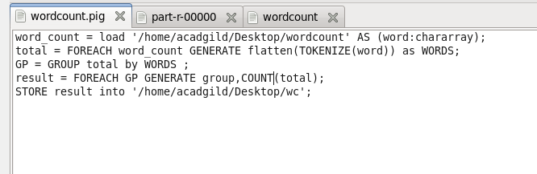

**STEPS**

Step 1: load command is used to load the file into word_count

Step 2 : TOKENIZE IS USED TO SPLIT THE CHARARRAY INTO MULTIPLE TUPLES AS SHOWN

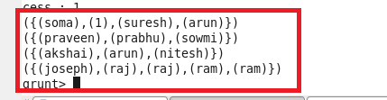

STEP 3 : FLATTEN IS USED TO UNNEST THE TUPPLES;

Step 4: It is then grouped as below

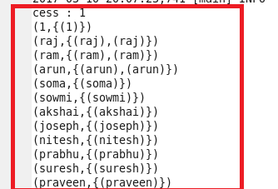

Step 5:Count is Made

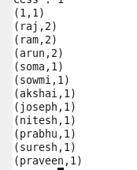

**EXECUTING THE PIG FILE IN TERMINAL**

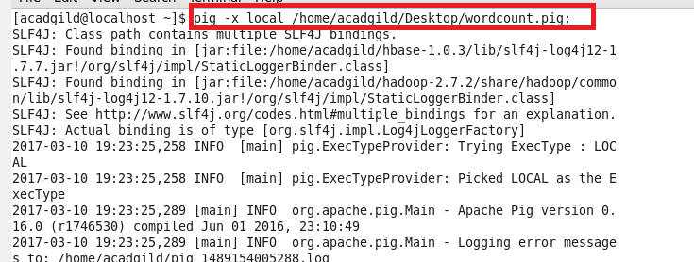

TASK EXECUTED SUCCESSFULLY

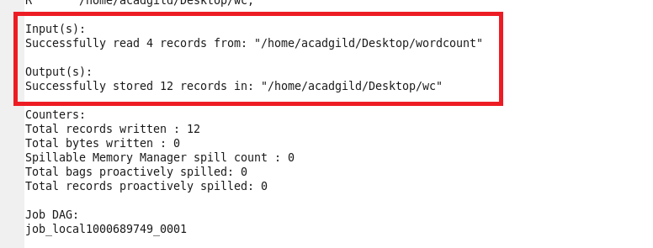

**OUTPUT**

